CubeMars AK80-8 — Data Capture Instructions

What this is for
This instruction sheet is on how to record serial data sent from the CubeMars motor to get certain bytes that allow us to change the parameters of the motor from our own GUI.

What you'll need
- The AK80-8 motor, powered on
- The R-Link adapter, connected via USB
- The CubeMars Upper Computer software
- Serial Port Monitor software
  - This is a free serial port monitor

Before you start
- Open the CubeMars Upper Computer software.
- Connect to the motor: select the correct COM port, confirm Servo Mode is selected (not MIT Mode), and click Connect.

How to capture the data needed.
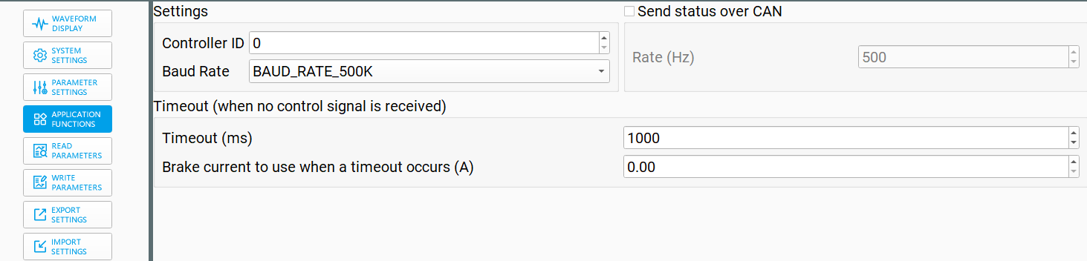
- On your upper computer software, make sure to go to the specific parameter that you are looking to capture, and press Read Parameters on the sidebar. (You need to press Read Parameters before Write Parameters; otherwise, it will cause the motor to malfunction)
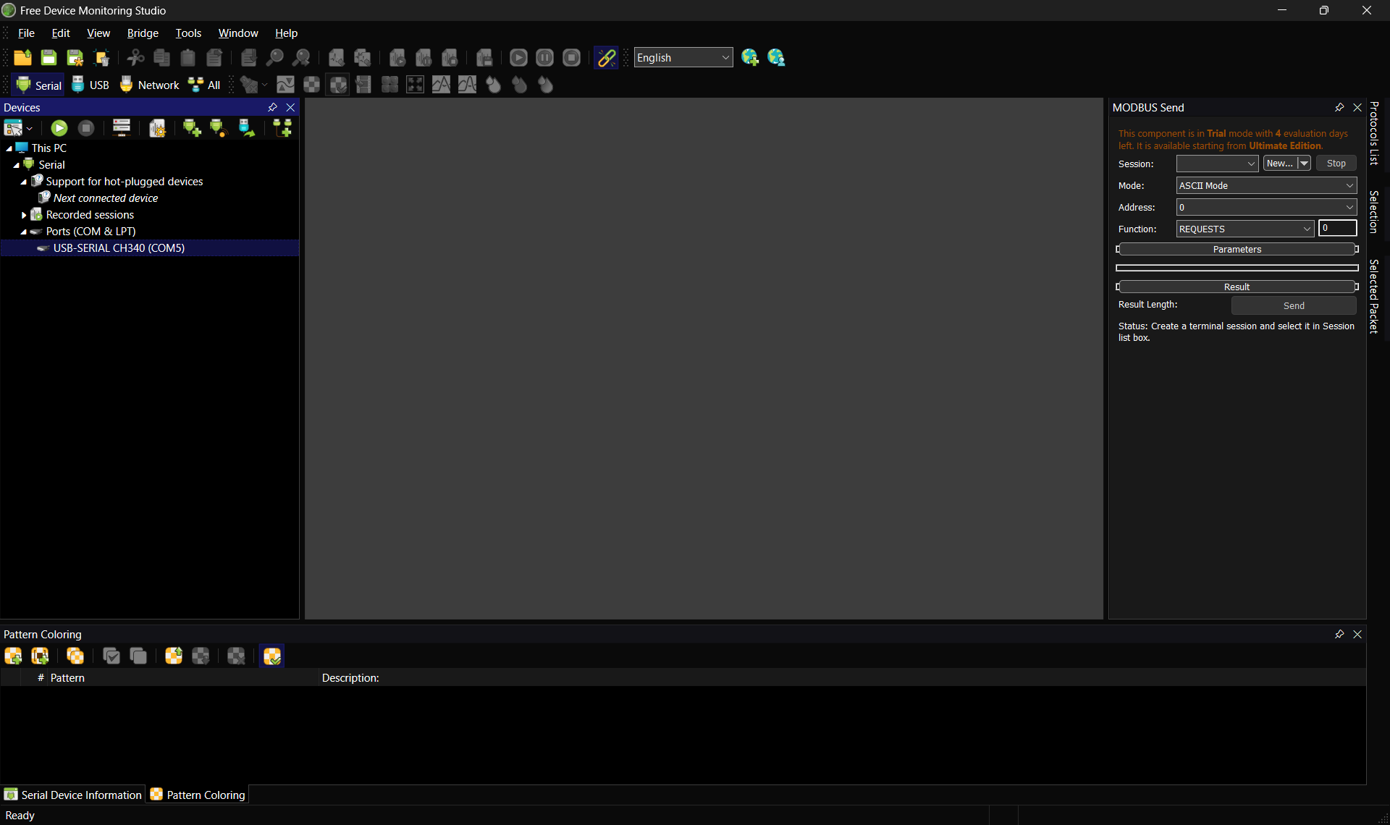
- Open your Serial port monitor, and this is how it should look
- Select the Port you want to use (In CubeMars' case, it should be something like USB-SERIAL CH340)
- Double-click on the port, and a window should pop up. The Baud rate can be left at 115200 because it doesn’t need to match the motor's real communication.
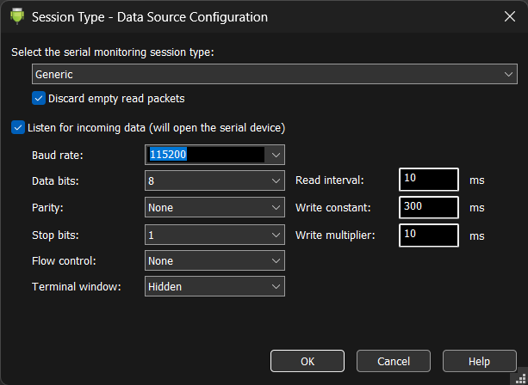
- Another window should show up which will ask you to select how you want to view the data and what type of data you want to capture
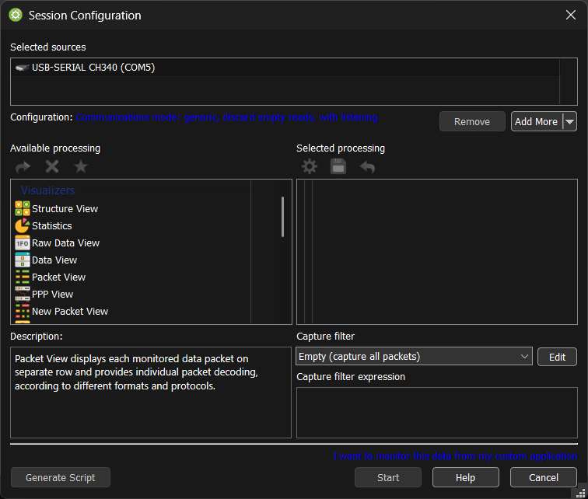
- Select Packet View, press the arrow to move it across, and then scroll down to Exporters and select Data recording. Move it across and press Start. This should cause the data to start capturing.

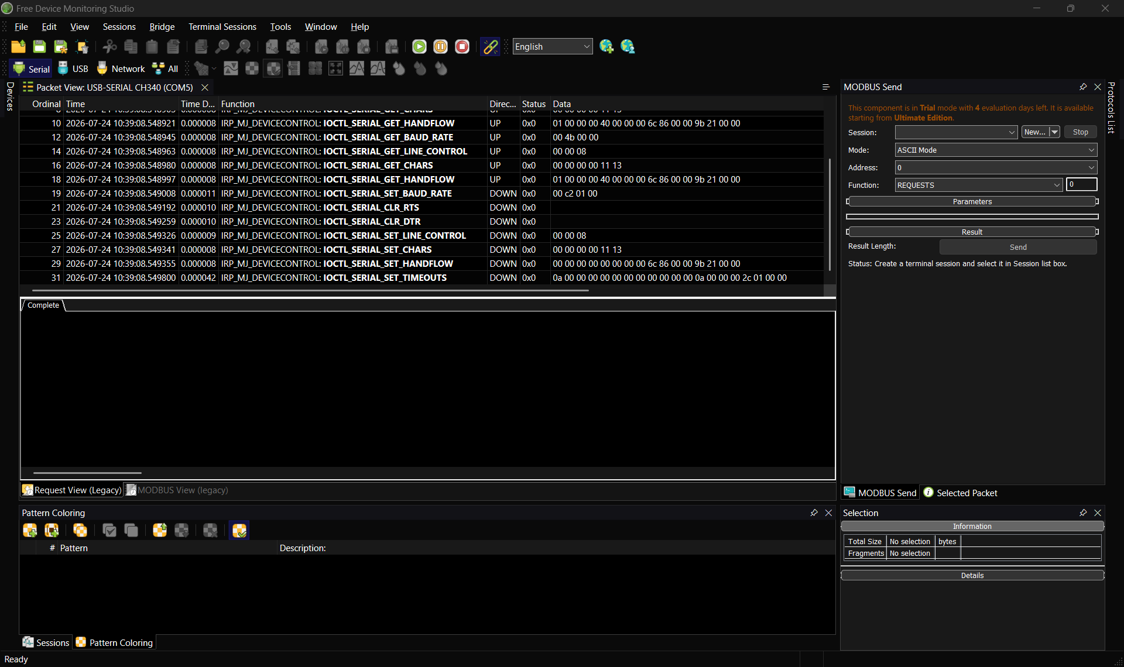
- This is how the capture should look.
- After it has started capturing, go back to your Upper Computer Software and change the parameter you are trying to get the data for. Make sure the change is clearly different from the value it is (another thing to be careful of is to make sure to press Enter after changing the value so that the software can register the change)
- Click on Write Parameters for the value to be written to the motor.
- Wait a couple of seconds, and then go to the Serial Port Monitor and press the pause button at the top of the capture.
- After the capture has paused, right-click on the Function tab, and then press Export on the dropdown menu that shows up.
- The file it needs to be saved with will automatically be selected (UNICODE Text File).
- Give it the name of the parameter being changed, then save it.

Before Next capture
Before starting the next capture, make sure you press the stop button on the serial port monitor so you can start a completely new capture and not reuse the one you just did. This is a crucial step; otherwise combing multiple values in the same capture makes it difficult to tell which byte belongs to which capture.

Also, make sure to press Read Parameters again before capturing.

Another helpful thing that can be done is noting down the value that was changed for the specific parameter so that it is easier to identify which values were changed (e.g., ‘changed from 0.00 to 5.00’)

